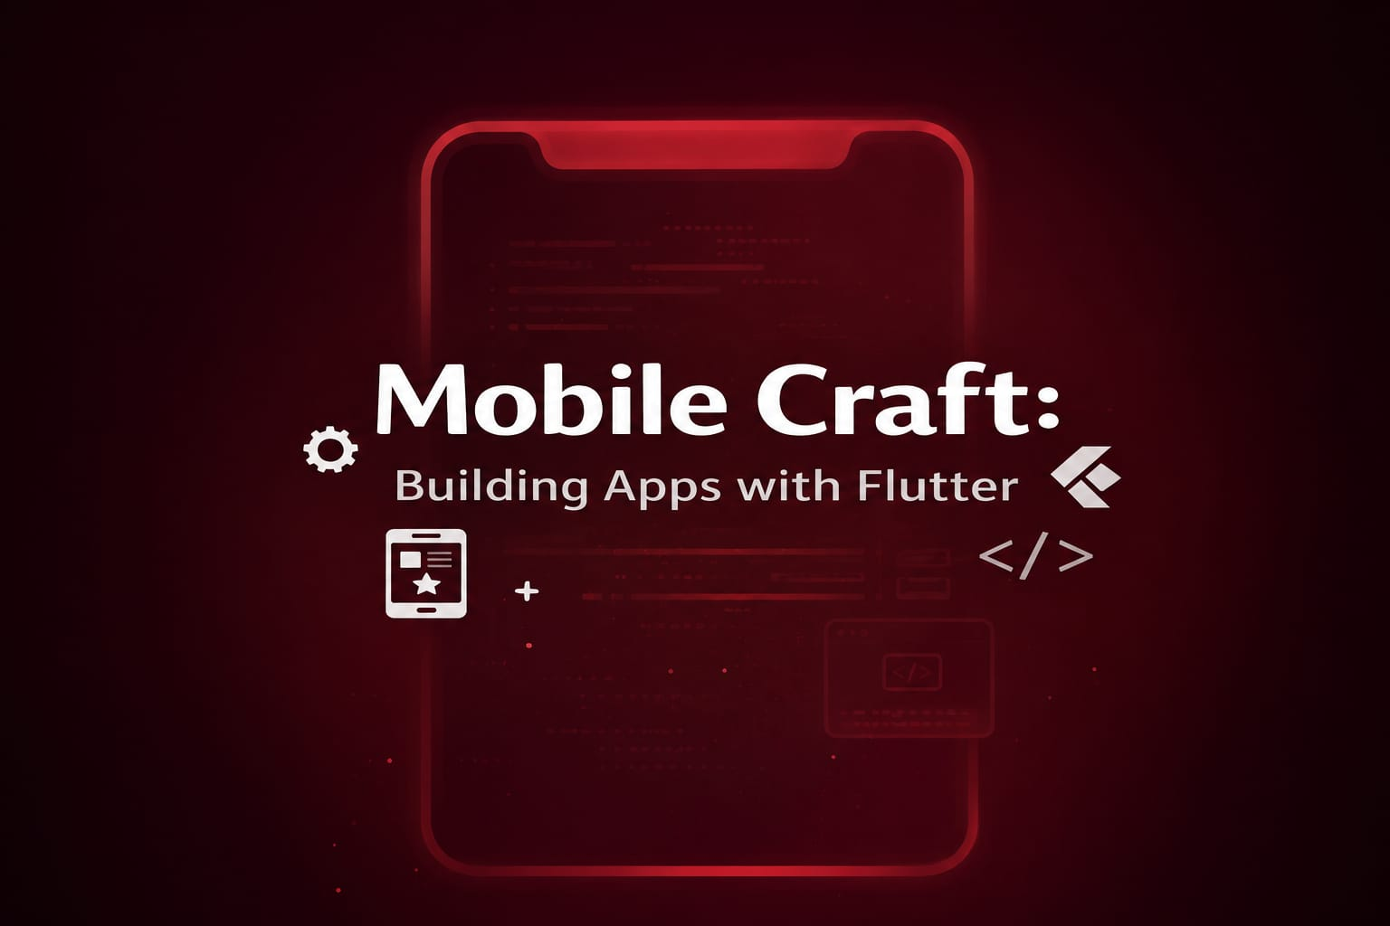

①Dart Programming and Flutter
②Interactive Applications & Widgets
③Flutter Navigation and Routes
④Working with ListViews
⑤Restful Services & Consuming REST API in Flutter

By Jawad Jammoul

